Master of Research Study
People with Intellectual
Disabilities and Social Media Use
Survey Participant Information Sheet


About our study

 | The University of Sydney is doing a research study on how people with  intellectual disabilities use social media.
 | We want to find out how social media helps you talk to others and express who you are online.

We want to find out what you like and don’t like when using social media.
 | This study will start in 2024 and finish in 2026.

 | As part of the research study, we want to talk to people with intellectual disabilities.
  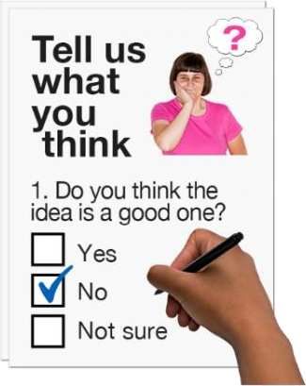 | We want people with intellectual disabilities to tell us about their experiences online and what is important to them.  We will do this by having surveys asking people to answer questions about their experiences on social media.

   | We will ask you questions about  - how you use social media  - why you use social media  - any challenges or benefits you experience on social media.  At the end of the survey, you will be given the option to be contacted to participate in a one-to-one interview.

What you have to do

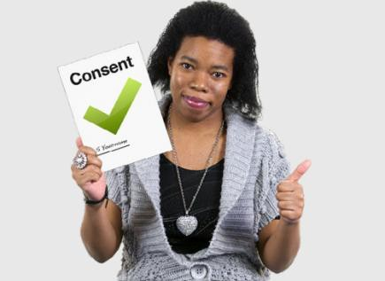 | If you choose to be part of the study, you will need to read the consent  statement beforehand.

 | The consent statement says that you  - understand what the research study is about  - want to be part of it.
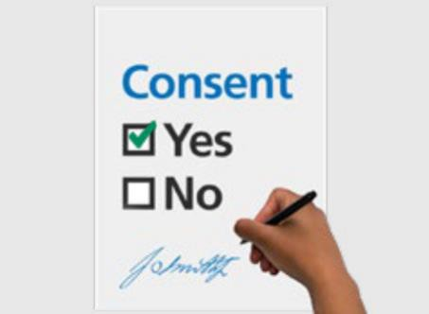 | If you choose to be part of the study you need to sign the consent  statement before starting the survey.

Who can be part of the research study

 | To be part of the study you must be an adult with intellectual disabilities.
 | You must be over the age of 18 to be a part of the study.

If you change your mind

 | You can decide if you would like to be a part of the research study.
 | No one will be upset with you if you do not take part.
 | You can decide if you do not want to be a part of the study at any time.
 | If you decide that you do not want to be a part of the study during the  interview you can let us know.

Support

   | We will help you get support if something about the research study makes you feel upset.  You can choose to have a support person if there is something that you do not understand.
 | You can tell us if there is something about the research study that you are not happy about.

After the study

 | The study will help us understand how to make social media better for people with intellectual disabilities.
 | To find out more about this study you can contact the research team at the University of Sydney.

 | You can email student researcher, Ryan David Andriesz or lead supervisor, Dr Catherine Page Jeffery.  - Ryandavid.andriesz@sydney.edu.au  - catherine.pagejeffery@sydney.edu.au

